DATE: July 14, 2018
SANCTION NO: PA18/111055
SPONSOR: Tahoe Trail Trekkers
LOCATION: Donner Camp Picnic Ground; Truckee, CA 96161 Nevada County: +39° 22' 32.32", -120° 10' 55.67"
~3 mi. north of Truckee on Hwy #89

START TIME: 9:00 a.m. – 1:00 p.m.
FINISH TIME: Finish by 4:00 p.m.
DISTANCE(S): 10K and 5K
SPECIAL PROGRAMS: Co: Nevada, Bridges, Boardwalks, Walking the USA A-Z “T”

TRAIL RATING & DESCRIPTION: Rated 1B Starting elevation 6,000 ft. *This is a section of a longer trail which parallels the routes taken by the emigrants in the mid 1800’s. Much of the original emigrant route has been obliterated by roads and reservoirs. (Fact taken from Sierra Club Trails)
Walk in a mostly level, forested area, on well maintained dirt trails. Enjoy the babbles of Alder Creek alongside the trail for much of the route, crossing over several wooden bridges. At the start/finish area, there is a loop trail with information and signs about the encampment of a portion of the ill-fated Donner Party during the winter of 1846-47. This is part of the walk route.

MISCELLANEOUS: Restrooms and water at start/finish. Bring water for the walk. No restrooms on the trail. Strollers and wheelchairs not recommended. Trail shared with mountain bikers. Dogs OK on leash with clean-up.
AWARD: This is a credit only event.
FEES: Credit only is $3.00. Pay by cash or check to the Tahoe Trail Trekkers. Anyone may participate for free if no credit is desired.

INFORMATION CONTACT: Betsy McDevitt
betsywalks@gmail.com 530-412-HIKE (4453)
Tahoe Trail Trekkers www.tahoetrailtrekkers.org

STIPULATIONS: With registration for these events, the participants accept the guidelines for AVA volkssport events and agree to observe the principles of good sportsmanship. Littering is prohibited. Children under 12 must be accompanied by an adult. If dogs are allowed, they must be on leash and you must clean up after them. This event is open to everyone.

EVENT CONDITIONS: This event will take place regardless of weather conditions. There will be no refund for credit fee.

DISCLAIMER: The sponsors are not liable for accidents, thefts, and/or material damage. Every reasonable effort will be made by the sponsors to make this a safe, enjoyable, and memorable event. A waiver must be signed by those participating in any event. A parent or guardian must sign for children under 18.

GENERAL INFORMATION

VOLKSSPORTS: Volkssports are organized, non-competitive events designed for people of all ages and abilities, to promote physical fitness and family fun. Events consist of walks, biking swims, kayaking or nordic skiing. All events are free and open to everyone.
New participants interested in participating for AVA credit ($3/event) may purchase a New Walker Packet containing both event and distance books and free walker coupons for $5. A $20 value.

SANCTION: The event in this brochure has been sanctioned by the American Volkssport Association (AVA), a member of the International Federation of Popular Sports (IVV), and count toward the acquisition of IVV achievement awards.

PROCEDURES: Register by filling out the registration log, signing the waiver and filling out a start card. ALL participants MUST CARRY A START CARD even if walking for free. All cards remain the property of the club and must be turned in upon completion of the event.

DIRECTIONS--From Sacramento: Take I-80 eastbound to Truckee exit #188B (Sierraville/89 north). Turn left at the end of the ramp. From Reno: Take I-80 westbound to Truckee exit #188 (Sierraville/89 north). Turn right at the end of the ramp. Both directions: Continue on State Route 89 north, forward through 2 roundabouts, ~ 2 miles to Donner Camp Picnic Ground on the right. Watch for AVA signs.
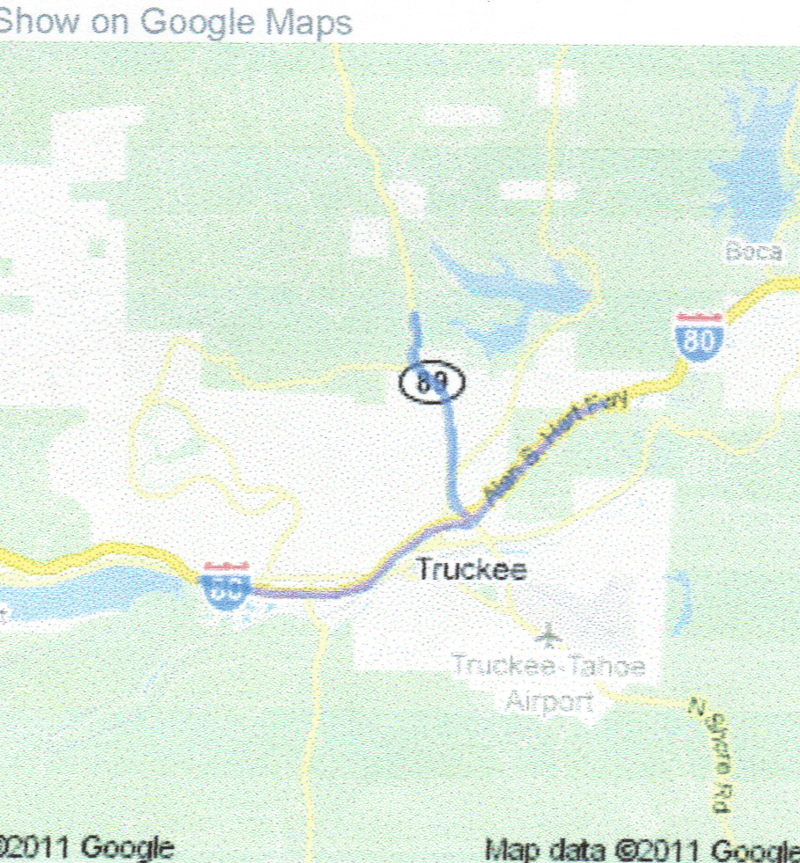

For Additional Fun!
There will be (group) “Friendship Walks” on….
Friday, July 13—Squaw Valley—Tahoma Seasonal YRE at noon. Sunday, July 15—Squaw Valley—Olympic Valley Seasonal YRE at 9:00 a.m.
*Each Squaw Valley YRE qualifies for the new “Walk Like an Olympian” special program.

The Tahoe Trail Trekkers #489 Present:
Commemorative
Emigrant Trail
Volkswalk -10k & 5k
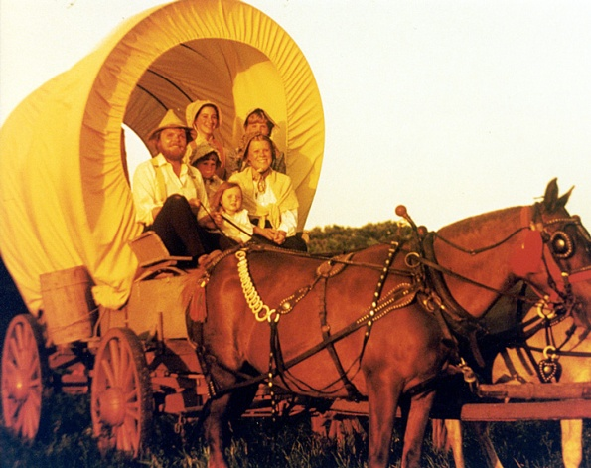

Donner Camp Picnic Ground, Truckee, CA
July 14, 2018
PA18/111055

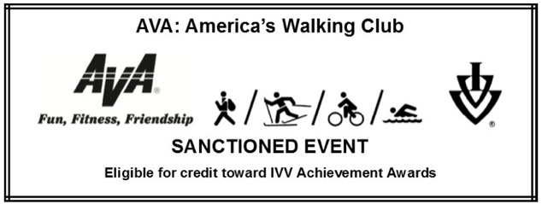

For more information on AVA visit www2.ava.org

